**Insert a map of your route here**

Routes should take anywhere from 30 minutes to two hours to complete and will ideally be a looped route. An example route is pictured below:

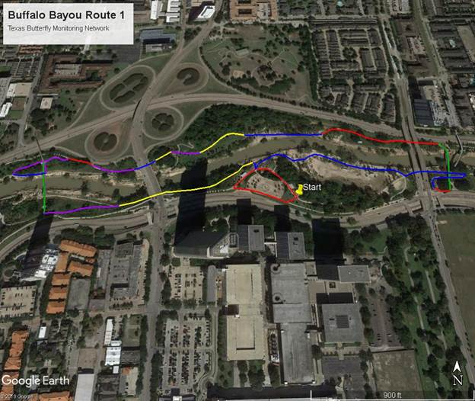

An ideal route is in a natural or semi-natural area and goes through several different habitats. Each of the colors on the route above designates a habitat. You get to pick your own habitat labels, and we ask that you have five different habitats. My habitats for the attached map are listed below:

Habitat A (red): Roadside

Habitat B (blue): Sandy floodplain

Habitat C (green): Man-made bridges

Habitat D (yellow): Open Woodland

Habitat E (purple): Marsh

If you do not want to choose your own route, you can request a pre-mapped route in a particular area, and we will be able to assign you one.